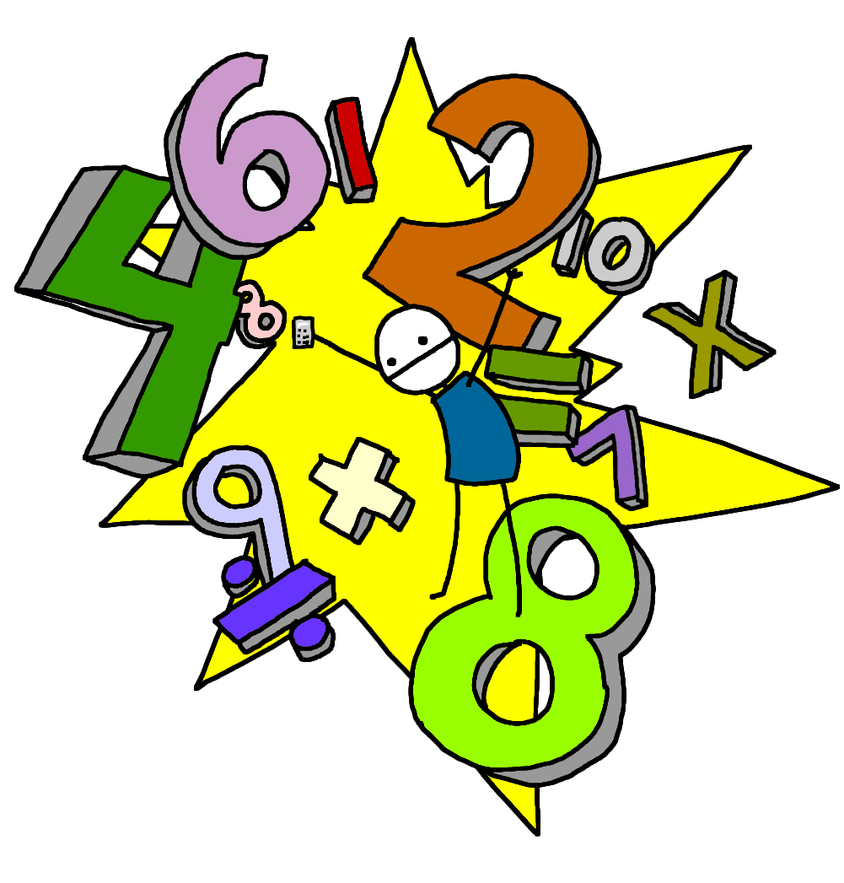
Morning Maths Workout!

Adding and subtracting 10

24 + 10 =
38 + 10 =
26 + 10 =
63 + 10 =
45 + 10 =
27 + 10 =
14 + 10 =
29 + 10 =
46 + 10 =

46 – 10 =
24 – 10 =
33 – 10 =
48 – 10 =
35 – 10 =
42 – 10 =
81 – 10 =
53 – 10 =
34 – 10 =

23 – 10 =
6 + 10 =
15 – 10 =
28 – 10 =
2 + 10 =
4 + 10 =
17 – 10 =
1 + 10 =
12 – 10 =

