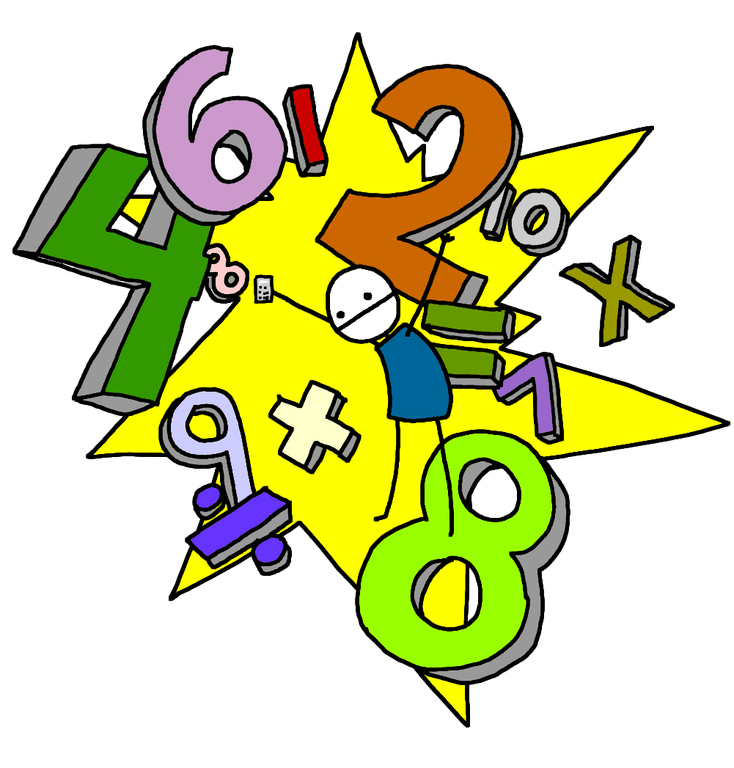
Morning Maths Workout!

Adding and subtracting multiples of 10

24 + 20 =
38 + 40 =
26 + 30 =
63 + 20 =
45 + 50 =
27 + 20 =
14 + 30 =
29 + 60 =
46 + 30 =

46 – 20 =
24 – 10 =
63 – 20 =
58 – 30 =
85 – 50 =
62 – 40 =
81 – 30 =
53 – 20 =
74 – 20 =

34 – 30 =
6 + 50 =
48 – 30 =
28 – 10 =
2 + 40 =
7 + 10 =
13 – 10 =
8 + 10 =
47 – 30 =

