Apple Class Home Learning Task Spring 1 (to be completed by February half term)

SPACE
This half term, the children’s self-chosen topic is ‘Space’. They have asked to learn about space rockets, aliens, planets and the stars.

Therefore, for our home learning task, we would like you to complete at least one of the following:

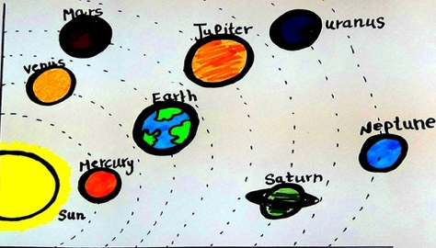
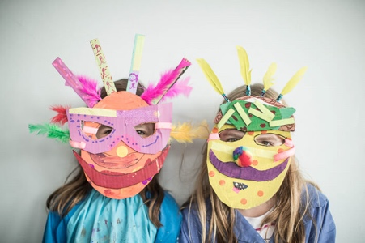

Design and make an alien mask. Draw or Collage a Create and label a space scene and add add labels to it.
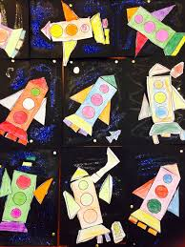

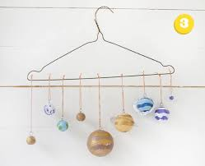

Create a representation of the planets Use 2D Shapes to make planets
in our solar system. make a space picture.

We look forward to seeing the results in class!

Thank you The Reception Team

