(School can nsert logo) 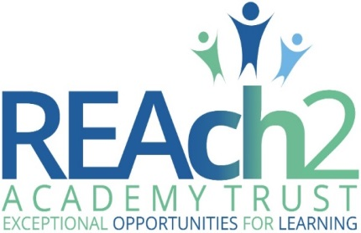

Collective Worship Policy

Audience: | Parents  School staff  Local Governing Bodies  Trustees  Regional Boards  Local Authorities
Approved: | Trust Board – July 2017  Local Governing Body (LGB) – December 2019  Headteacher – October 2019
Other related policies: | SMSCD, PSHCE, RE
Policy owner: | Simon Wood, Regional Director
Review: | Every 3 years or more frequently if national policy requirements change
Version number: | 1.0 July 2017

REAch2 Collective Worship Policy | 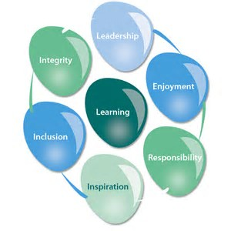

At REAch2, our actions and our intentions as school leaders are guided by our Touchstones:

Integrity | We recognise that we lead by example and if we want children to grow up to behave appropriately and with integrity then we must model this behaviour
Responsibility | We act judiciously with sensitivity and care. We don’t make excuses, but mindfully answer for actions and continually seek to make improvements
Inclusion | We acknowledge and celebrate that all people are different and can play a role in the REAch2 family whatever their background or learning style
Enjoyment | Providing learning that is relevant, motivating and engaging releases a child’s curiosity and fun, so that a task can be tackled and their goals achieved
Inspiration | Inspiration breathes life into our schools. Introducing children to influential experiences of people and place, motivates them to live their lives to the full
Learning | Children and adults will flourish in their learning and through learning discover a future that is worth pursuing
Leadership | REAch2 aspires for high quality leadership by seeking out talent, developing potential and spotting the possible in people as well as the actual

POLICY OVERVIEW

Overarching Principles

REACh2 Academy Trust believes that collective worship both supports and strengthens what we aim to do in every aspect of school life. Our caring ethos and the value which we place on the development of the whole child; spiritually, morally, socially, culturally and intellectually is reflected in our worship. We value this special time in the school day for the space it gives children to develop a reflective approach to life and the ability to express their reflections in traditionally religious ways or any other appropriate manner.

It is a legal requirement that all registered school age pupils take part in an act of worship each day. These acts of worship must be “wholly or mainly of a broadly Christian character” for the majority of the time. They must also be “appropriate, having regard to the ages, aptitudes and family backgrounds of the pupils”.

We recognise that in asking our children to worship we have to consider the background that our children come from and it is therefore not the practice of our Trust/this school to preach to or convert the children. The faith background of both the staff and the child’s family is respected at all times.

AIMS:
Through our collective worship we aim to provide a caring and supportive environment for children to:
- Become increasingly aware of themselves as individuals and groups within the school and wider community
- Grow in understanding of the feelings of other people in every day situations and beliefs
- Explore the language which people use to express their feelings
- Deepen their sense of wonder about the world around them
- Grow in confidence when making a presentation to the group or whole school
- Respond freely to religious and/or spiritual stimulus
- Acknowledge diversity and affirm each person’s life stance, whether it be religious or not

Intended impact
Over time, our collective worship provision will support our vision of ‘exceptional opportunities for learning’.

Roles & responsibilities

Pupils will: be offered, and enagage fully with, collective worship experiences that promote self-esteem, independence, perseverance, self-discipline, tolerance and a lifelong love of learning

Parents/carers will: support and work with the academy to ensure that such activity is highly valued by them and their children; to ensure children develop into successful learners, confident individuals and responsible citizens

REAch2 schools will: ensure all pupils have access to collective worship opportunities, in-line with Local Authority agreed syllabi

REAch2 central staff will: support pupils, families and schools in achieving this, ensuring this is embedded and is sustainable

REAch2 non-executives will: hold central staff members to account for rigorous monitoring and quality assurance; evidencing increasing impact on high quality provision and pupil outcomes over time.

How this relates to national guidance & requirements

National Curriculum 2014
Teachers Standards 2012
National Standards of Excellence for Headteachers
Hertfordshire Agreed Collective Worship Syllabus

