Garden City Academy
Calculation Policy
Autumn 2018

Rationale
This policy outlines a model progression through written strategies for addition, subtraction, multiplication and division expected to be taught at Garden City Academy (GCA), this is in line with the National Curriculum 2014. Through the policy, we aim to link key manipulatives and representations in order that the children can be vertically accelerated through each strand of calculation. This should help consistency of approach, enabling children to progress stage by stage through models and representations they recognise from previous teaching, allowing for deeper conceptual understanding and fluency. As children move at the pace appropriate to them, teachers will be presenting strategies and equipment appropriate to children’s level of understanding. However, it is expected that the majority of children in each class will be working at age-appropriate levels as set out in the National Curriculum 2014 and in line with school policy.

The importance of mental mathematics
While this policy focuses on written calculations in mathematics, we recognise the importance of the mental strategies and known facts that form the basis of all calculations. As a school we will be using the Times Table Rockstars online programme to support pupils with their times table recall, this will be done both online and through times table skills tests in the classroom on a regular basis. The following checklists outline the key skills and number facts that children are expected to develop throughout the school.

Times tables should be taught by the end of:
Year 2 - 2's, 3's, 5's and 10's
Year 3 - 2's, 3's, 4's, 5's, 8's and 10's
Year 4 - all of the above plus 6's, 7's, 9's, 11's and 12's
Year 5/6 – application of these times tables

To add and subtract successfully, children should be able to:
- recall all addition pairs to 9 + 9 and number bonds to 10
- recognise addition and subtraction as inverse operations
- add mentally a series of one digit numbers (e.g. 5 + 8 + 4)
- add and subtract multiples of 10 or 100 using the related addition fact and their knowledge of place value (e.g. 600 + 700, 160 — 70)
- partition 2 and 3 digit numbers into multiples of 100, 10 and 1 in different ways
(e.g. partition 74 into 70 + 4 or 60 + 14)
- use estimation by rounding to check answers are reasonable

To multiply and divide successfully, children should be able to:
- add and subtract accurately and efficiently
- recall multiplication facts to 12 x 12 = 144 and division facts to 144 ÷ 12 = 12
- use multiplication and division facts to estimate how many times one number divides into another etc.
- know the outcome of multiplying by 0 and by 1 and of dividing by 1
- understand the effect of multiplying and dividing whole numbers by 10, 100 and later 1000
- recognise factor pairs of numbers (e.g. that 15 = 3 x 5, or that 40 = 10 x 4) and increasingly able to recognise common factors
- derive other results from multiplication and division facts and multiplication and division by 10 or 100 (and later 1000)
- notice and recall with increasing fluency inverse facts
- partition numbers into 100s, 10s and 1s or multiple groupings
- understand how the principles of commutative, associative and distributive laws apply or do not apply to multiplication and division
- understand the effects of scaling by whole numbers and decimal numbers or fractions
- understand correspondence where n objects are related to m objects
- investigate and learn rules for divisibility

NC Exemplar
Children should only be encouraged to go on to the next calculating stage if:
- They are ready
- They are confident
- They understand the mathematical theory behind the practice.

In order to become confident, efficient and accurate mathematicians, children at GCA will be encouraged to:
- Approximate their answers before calculating.
- Check their answers after calculation using an appropriate strategy.
- Consider if a mental calculation would be appropriate before using written methods.

This policy is intended as a working document, to aid all staff and parents/guardians, in understanding the development of skills and progression of informal and formal written calculation methods. However, within the structure of this progression, allowance must be made for children’s personal methods of recording, ensuring that alternatives are both clearly understood and efficient. Where possible, calculations will be taught within a real life context, to enhance awareness of mathematical skills as a part of everyday life.

Recording methods guidance for written calculation strategies Foundation Stage to Year 6

EYFS | YEAR 1 | YEAR 2 | YEAR 3 | YEAR 4 | YEAR 5 | YEAR 6
DRAWING PICTURES AND MARKS
EXPLAINING IN WORDS
 | USING SIGNS AND SYMBOLS
 | DRAWING NUMBER LINES
 |  | USING INFORMAL JOTTINGS AND MODELS
USING FORMAL WRITTEN CALCULATION METHODS
(All methods taught by end of Y5 (except long division,
Y6) enabling children to apply strategies as they see fit.)

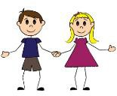
Early Years
Addition  + | Subtraction  – | Multiplication  x | Division  ÷
Children are expected to work with numbers from 0-20.  Pictures/symbols/objects  Children represent work by drawing the work that has been done practically  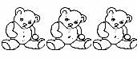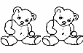  e.g.  I had three teddies. My mum gave me two more. I now have 5 teddies.  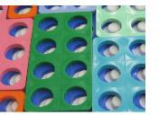  Numicon shapes are connected in order to represent an addition calculation.  Children are encouraged to develop a mental picture of the number system in their heads to use for calculation.  They develop ways of recording calculations using pictures and marks.  Bead strings being used to illustrate addition.  This leads onto number line work.  Child can say ‘5 and 3 make 8’ | Children are expected to work with numbers from 0-20.  Pictures/symbols/objects Children represent work by drawing work done practically. e.g.  There were 9 balloons, 3 popped 6 balloons are left.  Children are encouraged to develop a mental picture of the number system in their heads to use for calculation.  They develop ways of recording calculations using pictures etc.  Bead strings being used to illustrate subtraction.  This leads onto number line work.  Child can say ‘9 take away 3 leaves 6’ | Children are expected to work with numbers from 0-20.  Pictures/symbols/objects  Children will experience equal groups of objects. They will count in 2s and  10s and begin to count in 5s.  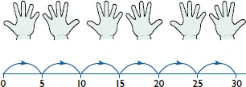  Children can use the language of doubling.  Child can say ‘I have double the number of foxes. Double 1 is 2.  They will work on practical problem solving activities involving equal sets or groups. | Children are expected to work with numbers from 0-20.  Pictures/symbols/objects Children will understand equal groups and share items out in play and problem  solving.  Grouping  NB – Although the NC saus ‘Sharing’ we prefer ‘grouping’. This helps the child to link division with  multiplication.  Children need to understand that grouping means the same amount in each group.  Children use the language of halving  e.g. Put six plums into two equal groups. How many plums does each child get?  Child can say ‘3 each’.  Half of 6 is 3  Grouping eight into twos, Child can say ‘4 groups’.

Year 1
Addition  + | Subtraction  – | Multiplication  x | Division  ÷
Represent and use number bonds and related subtraction facts within 20  Count to and across  100, forwards and backwards, beginning with 0 or 1, or from any given number.  Pictures/symbols/objects  3 + 4 = = 3 + 4  3 + = 7 7 = + 4  + 4 = 7 7 = 3 +  + ∇ = 7 7 = + ∇  Encourage the use of concrete objects and pictorial representations. e.g. bead strings, counters, number lines, number tracks, Numicon, hundred squares  e.g. 12 + 8 =   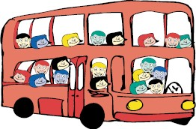  Child can say ‘15 and 3 make 18’  Read, write and interpret mathematical statements involving addition (+), subtraction (-) and equals (=) signs | Represent and use number bonds and related subtraction facts within 20  Count to and across  100, forwards and backwards, beginning with 0 or 1, or from any given number.  Pictures/symbols/objects  7 - 3 = = 7 - 3  7 - = 4 4 = - 3  - - 3 = 4 4 = 7 -  - - ∇ = 4 4 = - ∇  Encourage the use of concrete objects and pictorial representations. e.g. bead strings, counters, number lines, number tracks, numicon, hundred squares  Sam spent 4p. How much did he have left from 10p?  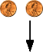  Child can say ‘19 take away 7 leaves 12’  Read, write and interpret mathematical statements involving addition (+), subtraction (-) and equals (=) signs | Solve one-step problems involving multiplication by calculating the answer using concrete objects, pictorial representations and arrays with the support of the teacher.  Pictures/symbols/objects  Use visual and concrete arrays and sets of resources to find ‘2 lots of 5, 3 lots of 4 etc.)  e.g. There are 3 marbles in every bag. How many marbles are there in 4 bags?  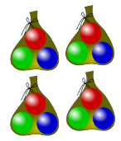  Practical activities involving counting, using numicon and other resources.  Counting in 2s  e.g. counting socks, shoes, animals’ legs… Counting in 5s  e.g. counting fingers, gloves, toes… Counting in 10s  e.g. fingers, toes… | Solve one-step problems involving division, by calculating the answer using concrete objects, pictorial representations and arrays with the support of the teacher.  Pictures/symbols/objects  15 children get into teams of 5 to play a game. How many teams are there?  Practical activities involving grouping. Distributing cards when playing a game, sorting objects onto plates, into cups, hoops etc.  Grouping  NB – Although the NC saus ‘Sharing’ we prefer ‘grouping’. This helps the child to link division with  multiplication.  Children must understand that grouping requires the same amount in each group.  Sorting small numbers of objects into equal size groups.  There are six coins. How can I group them equally?

Addition + | Subtraction – | Multiplication x | Division ÷
Number Lines  Children should be encouraged to bridge through 10 | Number Lines  Children should be encouraged to bridge through 10 | Number Lines  There are five pairs of socks. How many socks are there altogether?  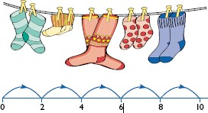  Children can count on in equal steps recording each jump on an empty number line. This shows five jumps of two.  Doubling  Multiplication is related to doubling and counting groups of the same size. | Group 15 marbles into 5. How many in each group?
e.g. 7 + 4 =  | 11 – 4 =   (Counting back) |  | 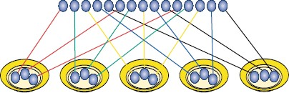
0 1 2 3 4 5 6 7 8 9 10 11 12 | 0 1 2 3 4 5 6 7 8 9 10 11 12
 |  |  | There are 3 marbles in each group.
Record drawing jumps on prepared lines or constructing own lines. | The difference between 7 and 11 (Counting up)  0 1 2 3 4 5 6 7 8 9 10 11 12  Record drawing jumps on prepared lines or constructing own lines. |  | Halving  Children need to understand halving as having two equal groups and  that it is the inverse of doubling
Establish that addition and subtraction are related operations.  Encourage estimation and the use of inverse to check answers.  Ensure that children know that addition is commutative (can be done in any order). | Establish that addition and subtraction are related operations.  Encourage estimation and the use of inverse to check answers.  Ensure that children know that subtraction is non-commutative (cannot be done in any order). | 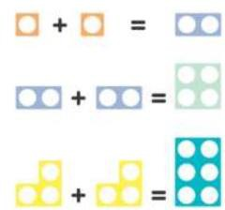  Encourage estimation and the use of inverse to check answers.  Ensure that children know that multiplication is commutative (can be done in any order). | Encourage estimation and the use of inverse to check answers.  Ensure that children know that division is non-commutative (cannot be done in any order).
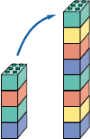
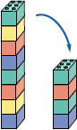

YEAR TWO
Addition  + | Subtraction  – | Multiplication  x | Division  ÷
Recall and use addition and subtraction facts to 20 fluently, and derive and use related facts up to 100  Add and subtract numbers using concrete objects, pictorial representations, and mentally.  Pictures/symbols/objects  Continue using a range of calculations as in Year 1 but with appropriate size numbers:  A two digit number and ones 14cm + 5cm = 19cm  A two-digit number and tens 24m + 30m = 54m  Two two-digit numbers 78p = 35p + 43p  Adding three one-digit numbers  £21 = £7 + £  + £5  Blank Number Lines  12 + 23 = 35  +10 +2  23 33 35 | Recall and use addition and subtraction facts to 20 fluently, and derive and use related facts up to 100  Add and subtract numbers using concrete objects, pictorial representations, and mentally.  Pictures/symbols/objects Continue using a range of calculations as in Year 1 but with appropriate size numbers:  A two digit number and ones 27 – 9 = 18  A two-digit number and tens 68km – 10km = 58km Two two-digit numbers  45p – 22p = 23p  p = 37p – 25p  Blank Number Lines  42 - 6 =  The difference between 46  and 33 is.  Counting back:  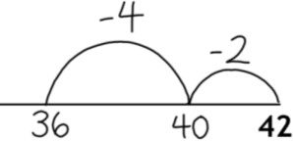  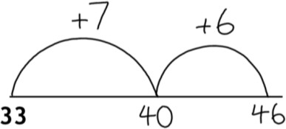 | Recall and use multiplication and | Recall and use multiplication and
 |  | division facts for the 2, 5 and 10 | division facts for the 2, 5 and 10
 |  | multiplication tables, including | multiplication tables, including
 |  | recognising odd and even numbers. | recognising odd and even numbers.
 |  | Pictures/symbols/objects | Pictures/symbols/objects
 |  | Continue using a range of calculations as | Continue using a range of calculations as
 |  | in Year 1 but with appropriate size | in Year 1 but with appropriate size
 |  | numbers. | numbers.
 |  | 7 x 2 = = 2 x 7 | 6 ÷ 2 = = 6 ÷ 2
 |  | 7 x = 14 14 = x 7 | 6 ÷ = 3 3 = 6 ÷
 |  | - x 2 = 14 14 = 2 x | - ÷ 2 = 3 3 = ÷ 2
 |  | - x ∇ = 14 14 = x ∇ | - ÷ ∇ = 3 3 = ÷ ∇
 |  | Make sure children practise written | Make sure children practise written
 |  | methods with 2, 5 and 10 x tables | methods with 2, 5 and 10 x tables
 |  | Blank Number Lines | Blank Number Lines
 |  | Repeated addition | Grouping using a number line
 |  | 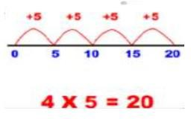 | 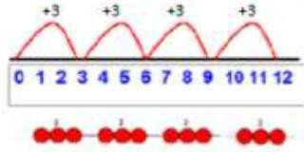  Pose 12 ÷ 3 as ‘How many groups of 3 in 12?
 |  |  | Group from 0 in equal jumps to find
 |  | 5+5+5+5 = 20 | ‘How many groups of in
 |  | 4 x 5 or 5 x 4 = 20 | 12 ÷ 3 = 4

‘100 Square’ model Move down to count ten, and to the right to count ones.  Partitioning  14 + 53 = 10 + 4 + 50 + 3  = 60 + 7  = 67  Refine to partitioning second number only  53 + 14 = 53 + 10 + 4  = 63 + 4  = 67  Adjusting (‘Spider Maths’ on Hundred square)  Add 9 or 11 by adding 10 and adjusting by 1  33 + 9 = 44  33 + 10 = 45  then 1 less than 45 is 44  Fact Families  7 + 13 = 20  So I know that 20 – 13 = 7  And 13 + 7 = 20  And 20 + 3 = 17  Encourage estimation and the use of inverse to check answers.  Ensure that children know that addition is commutative (can be done in any order) | ‘Bead string’ model  Take away a two- digit number in lots of ten and ones.  Partitioning Partition second number only: 41 – 12  = 41 – 10 – 2  = 31 – 2  = 29  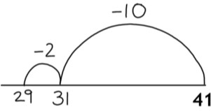  Adjusting (‘Spider Maths’ on Hundred square)  Subtract 9 or 11 by subtracting 10 and adjusting by 1  54 – 9 = 45  54 – 10 = 44  44 + 1 = 45  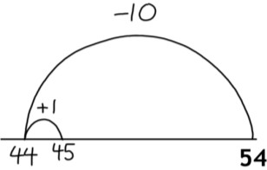  Encourage estimation and the use of inverse to check answers.  Ensure that children know that subtraction is non-commutative (cannot be done in any order). | Arrays (Use Numicon)  4 x 2 or 2 x 4  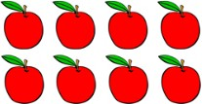  Key vocab: groups of, columns, rows  Doubling  Children should know that doubling is the same as multiplying by 2.  Doubles to 30 + 30 Doubles of multiples of ten to 100  Encourage estimation and the use of inverse to check answers.  Ensure that children know that multiplication is commutative (can be done in any order). | Grouping  NB – Although the NC says ‘Sharing’ we prefer ‘grouping’. This helps the child to link division with  multiplication.  Children must understand that grouping requires the same amount in each group.  There are 30 balloons and 3 bags. How many balloons in each bag?  27 plums into 3 groups. How many in each group?  3 groups of 9.  Halving  Children should know that halving is the same as dividing by 2.  Halve numbers up to 30 Halves of multiples of ten to 100  Encourage estimation and the use of inverse to check answers.  Ensure that children know that division is non-commutative (cannot be done in any order).
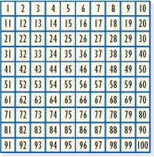
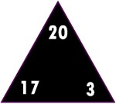
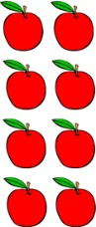
YEAR THREE
Addition  + | Subtraction  – | Multiplication  x | Division  ÷
Children are expected to work with numbers up to 1000  Pictures/symbols/objects Continue using a range of calculations as in Year 1 and 2 but with appropriate size  numbers.  Use dienes blocks where appropriate!  Partitioning and Number Lines  Partition both numbers and recombine. Partitioning the second number only as a more efficient way of adding on an empty number line.  e.g.  36 + 53 = 53 + 30 + 6  = 83 + 6  = 89  The nature of the numbers will define the appropriate strategy for the calculation (i.e. the biggest number does not always need to be placed first) | Children are expected to work with numbers up to 1000  Pictures/symbols/objects Continue using a range of calculations as in Year 1 and 2 but with appropriate size  numbers.  Use dienes blocks where appropriate!  Partitioning  Partitioning the second number only as a more efficient way of subtracting on an empty number line.  e.g.  97 – 15 = 72  97 – 10 = 87  87 – 5 = 82  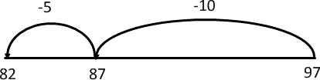  Number Lines  Make use of the knowledge of inverse by counting on (i.e. ‘find the difference’). e.g.  84 – 56 = | Recall and use multiplication and division facts for the 3, 4 and 8 multiplication tables.  Pictures/symbols/objects Continue using a range of calculations as in Year 1 and 2 but with appropriate size  numbers.  7 x 4 = = 4 x 7  7 x = 28 28 = x 7  - x 4 = 28 28 = 4 x  - x ∇ = 28 28 = x ∇  Two-digit numbers times one-digit numbers, using mental and progressing to formal written methods  Make sure you stick with 2, 3, 4, 5, 8 and  10 x tables  Number Lines  Number lines for repeated addition 16 x 3 = 48  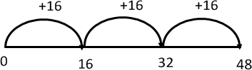  Partitioning  14 x 8  10 x 8 = 80  4 x 8 = 32  80 + 32 = 112 | Recall and use multiplication and division facts for the 3, 4 and 8 multiplication tables.  Pictures/symbols/objects Continue using a range of calculations as in Year 1 and 2 but with appropriate size  numbers.  12 ÷ 3 = = 12 ÷ 4  12 ÷ = 3 4 = 12 ÷  - ÷ 3 = 4 4 = ÷ 3  - ÷ ∇ = 3 4 = ÷ ∇  Grouping  (grouping from 0 on a horizontal or vertical vertical number line)  e.g. 38 ÷ 6 = 6 r2  How many left over when 38 is grouped into sixes?  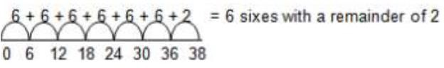  For larger numbers bigger jumps can be recorded using known facts.
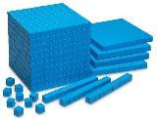

Column addition  Add numbers with up to three digits, using formal written methods of column addition. Include one decimal place (tenths) in written method problems  Children should start with the expanded method of column addition, after they have mastered partitioning  e.g. 53 + 84 = 137  50 + 3  + 80 + 4  100  100 + 30 + 7  Once they have mastered expanded method, they can move on to the compact method  Adjusting  Continue as in Year 2 but with appropriate numbers.  e.g.  35 + 19 is the same as 35 + 20 – 1.  44 + 58 is the same as 44 + 60 – 2  Fractions  Add fractions with the same denominator up to a whole.  E.g. | 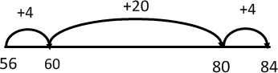  Column subtraction  Subtract numbers with up to three digits, using formal written methods of column subtraction. Include one decimal place (tenths) in written method problems  Children should start with the expanded method of column subtraction, after they have mastered partitioning and using a number line to find the difference.  e.g. 429 – 311 =  400 20 9  - 300 10 1  100 10 8 = 118  Once they have mastered expanded method, they can move on to the compact method, including using  decomposition (‘steal and bank’ or ‘take and make’ etc)  Adjusting  Continue as in Year 2 but with | Use known facts and place value (Scaling)  “If I know that 3 x 7 is 21, I also know: 30 x 7 = 210  3 x 70 = 210”  Having mastered the above, children can move on to using the formal ‘grid  method’  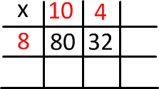  80 + 32 = 112  Arrays  4 x 12  or 12 x 4  or  12 + 12 + 12 +12  or  4 + 4 + 4 + 4 + 4 + 4 + 4 + 4 + 4 + 4 + 4 + 4  Fact Families  4 x 6 = 24  6 x 4 = 24  24 6 = 4  24 4 = 6 | 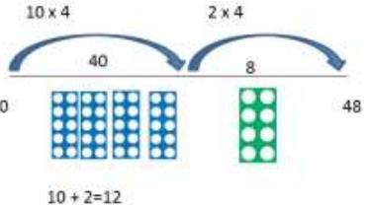  48 ÷ 12 = 4  Arrays  Grouping - How many 7s in 35?  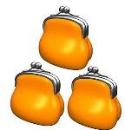  ‘The Bar Model’  (links to fractions of amounts)  A third of 39 is worth 13.  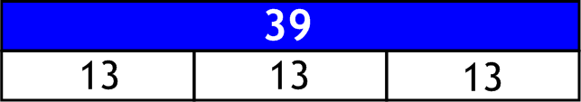  Use known facts  24 ÷ 4 the same as halving and halving again (i.e. quartering).  Fact Families  4 x 6 = 24  6 x 4 = 24  24 6 = 4  24 4 = 6
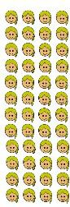
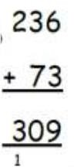
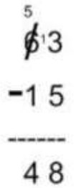
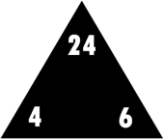

2/6 + 3/ 6 = 5/6  5/ 7 + 1/7 = 6/7  Encourage estimation and the use of inverse to check answers.  Ensure that children know that addition is commutative (can be done in any order). | appropriate numbers. e.g.  78 – 49 is the same as 78 – 50 + 1  Make use of known facts 50 -  = 26  I know that 50 – 25 = 25 and therefore I can adjust accordingly.  Fractions  Subtract fractions with the same denominator up to a whole.  e.g.  5/6 - 3/ 6 = 2/6  6/ 7 - 1/7 = 5/7  Encourage estimation and the use of inverse to check answers.  Ensure that children know that subtraction is non-commutative (cannot be done in any order). | Encourage estimation and the use of inverse to check answers.  Ensure that children know that multiplication is commutative (can be done in any order). | Encourage estimation and the use of inverse to check answers.  Ensure that children know that division is non-commutative (cannot be done in any order).

YEAR 4
Addition  + | Subtraction  – | Multiplication  x | Division  ÷
Add numbers with up to 4 digits using the formal written methods of column addition where appropriate  Include two decimal places (tenths & hundredths) in written method problems.  Pictures/symbols/objects Continue using a range of calculations as in Year 1, 2 and 3 but with appropriate  numbers.  Use dienes blocks where appropriate!  Partitioning and Number Lines  Partition both numbers and recombine. Partitioning the second number only as a more efficient way of adding on an empty number line.  e.g.  36 + 53 = 53 + 30 + 6  = 83 + 6  = 89 | Subtract numbers with up to 4 digits using the formal written methods of column Subtraction where appropriate  Include two decimal places (tenths & hundredths) in written method problems.  Pictures/symbols/objects Continue using a range of calculations as in Year 1, 2 and 3 but with appropriate  numbers.  Use dienes blocks where appropriate!  Partitioning and Number Lines Sarah was born in 2006 and Mark in 1998. How much older is Mark than Sarah? This can be represented on an  empty number line:  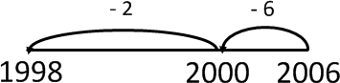 | Recall multiplication facts | Recall division facts for
 |  | for multiplication tables up to 12 × 12. | multiplication tables up to 12 × 12.
 |  | Pictures/symbols/objects
 |  | Continue using a range of calculations as | Pictures/symbols/objects
 |  | in Year 1, 2 and 3 but with appropriate | Continue using a range of calculations as
 |  | numbers. | in Year 1, 2 and 3 but with appropriate
 |  | 6 x 8 = = 8 x 6  6 x = 48 48 = x 6  - x 8 = 48 48 = 8 x  - x ∇ = 48 48 = x ∇ | numbers.  72 ÷ 8 = = 72 ÷ 9  72 ÷ = 8 9 = 72 ÷  - ÷ 8 = 9 9 = ÷ 8  - ÷ ∇ = 8 9 = ÷ ∇
 |  | Multiply two-digit / three-digit numbers
 |  | by a one-digit number | Divide two-digit / three-digit numbers by
 |  |  | a one-digit number.
 |  | Partitioning
 |  | 351 x 9 = 3159 | Divide by 10 or 100, including answers
 |  |  | with tenths and hundreths
 |  | 351 x 9 = | Slide the digits to the right.
 |  | 300 x 9 = 2700 | Once for x10, twice for x100, etc.
 |  | 50 x 9 = 450 | Explain that ‘tenths’ are less than one.
 |  | 1 x 9 = 9
 |  | 2700 + 450 + 9 = 3159  Multiply by 10 or 100  Slide the digits to the left.  Once for x10, twice for x100, etc. | 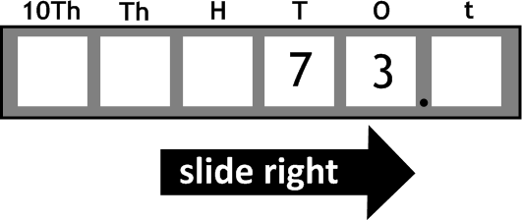  e.g. 73 ÷ 10 = 7.3
 |  | Fill in gaps with zeroes. | ‘The Bar Model’
 |  |  | (links to fractions of amounts)
 |  |  | A fifth of 150 is worth 30.

Column addition  Add numbers with up to 4 digits.  Revise expanded method to start with e.g. 4322 + 1856 =  4000 + 300 + 20 + 2  + 1000 + 800 + 50 + 6  1000  5000 + 100 + 70 + 8 = 5178 | Column subtraction (decomposition)  Subtract numbers with up to 4 digits.  Revise expanded method to start with e.g. 457 – 173 =  300  400 1 50 7  - 100 70 3  200 80 4 = 284 | e.g. 54 x 10 = 540 | Grouping  81 ÷3 = 27
(Extend to measures and decimals in the context of money)  Leading to compact version (when ready, starting with ‘friendly numbers’ i.e. no carrying):  6651  + 2879  1 1 1  9530  Fractions  Add fractions with the same denominator beyond one whole e.g.  5/6 + 3/ 6 = 1 and 2/6  6/ 7 + 5/7 = 1 and 4/7  Encourage estimation and the use of inverse to check answers.  Ensure that children know that addition is commutative (can be done in any order). | (Extend to measures and decimals in the context of money)  Leading to compact version (when ready, starting with ‘friendly numbers’ i.e. no decomposition)  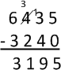  Fractions  Subtract fractions with the same denominator beyond one whole 1 and 5/6 – 3/6 = 1 and 2/6  1 and 3/ 7 – 6/7 = 4/7  Encourage estimation and the use of inverse to check answers.  Ensure that children know that subtraction is non-commutative (cannot be done in any order). | Grid Method  373 x 5 =  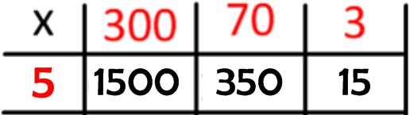  1500 + 350 + 15 = 1865  Start with calculations where the children will be able to add mentally.  Move on to short multiplication if and when children are confident multiplying using grid  Encourage estimation and the use of inverse to check answers.  Ensure that children know that multiplication is commutative (can be done in any order) | Short Division  After mastering grouping children may move on to short division  Limit numbers to NO remainders in the answer OR carried (each digit must be a multiple of the divisor)  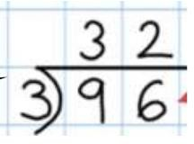  Carefully move onto examples requiring carrying (Use numicon to help illustrate)  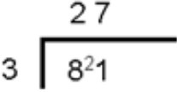  Ensure that children know that division is non-commutative (cannot be done in any order).
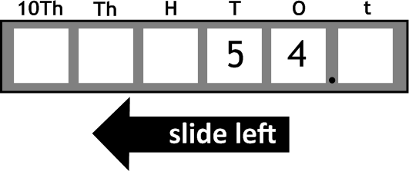
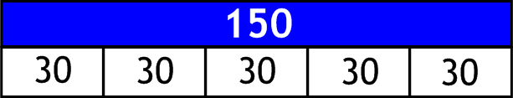
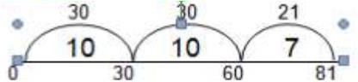

Year 5
Addition  + | Subtraction  – | Multiplication  x | Division  ÷
Add whole numbers with more than 4 digits, including using formal written methods (column addition)  Include three decimal places (tenths & hundredths and thousandths) in written method problems  Pictures/symbols/objects Continue using a range of calculations as in Year 1, 2, 3 and 4 but with appropriate  numbers.  Column addition  Add numbers more than 4 digits.  When the child is ready to move on from the expanded method (see Year 4):  e.g. 6651 + 2879 =  6651  + 2879  1 1 1  9530  Revert to expanded methods if the children experience any difficulty. Extend to decimals (same number of decimals places) and adding several numbers (with different numbers of digits). | Subtract whole numbers with more than 4 digits, including using formal written methods (column subtraction)  Include three decimal places (tenths & hundredths and thousandths) in written method problems  Pictures/symbols/objects Continue using a range of calculations as in Year 1, 2, 3 and 4 but with appropriate  numbers.  Column subtraction (decomposition) Subtract numbers with more than 4 digits.  When the child is ready to move on from the expanded method (see Year 4):  e.g. 8672 - 7679 =  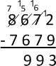  Revert to expanded methods if the children experience any difficulty. Extend to decimals (same number of decimals places). | Multiply numbers mentally | Divide numbers mentally drawing upon
 |  | drawing upon known facts (scaling) | known facts.
 |  | e.g. 7 x 6 = 42 | e.g. 63 ÷ 9 = 7
 |  | therefore 70 x 600 = 42000 | therefore 630 ÷ 9 = 70
 |  | Pictures/symbols/objects | Pictures/symbols/objects
 |  | Continue using a range of calculations as | Continue using a range of calculations as
 |  | in Year 1, 2, 3 and 4 but with appropriate | in Year 1, 2, 3 and 4 but with appropriate
 |  | numbers. | numbers.
 |  | Multiply numbers up to 4 digits by a one- | Divide numbers up to 4 digits by a one-
 |  | or two-digit number using an efficient | digit number using the efficient written
 |  | written method, including long | method of short division and interpret
 |  | multiplication for two-digit numbers. | remainders appropriately for the
 |  |  | context.
 |  | Grid Method
 |  |  | ‘Bus Stop’ short method
 |  | Extend to simple decimals with one | NB: ‘Bus Stop’ is a trick and does not rely
 |  | decimal place. | on place value.
 |  | e.g. 23.3 x 7 = 163.1  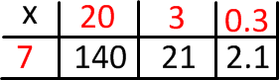 | 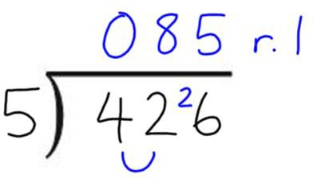
 |  | Short Multiplication  Carrying numbers underneath.  e.g. 256 x 3 = | Starting from the left hand side of the amount, ask  yourself:  “How many fives in 4?”  The answer is ‘none’. So you record a 0 above the
 |  |  | 4 and then link the 4 to the 2 to show 42.
 |  |  | “How many fives in 42?”
 |  |  | The answer is ‘8’ because 8 x 5 = 40. So you record
 |  |  | an 8 above the 2. Then carry the remaining 2,

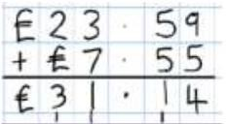  Partitioning  Partition the second number only e.g.  358 + 73 = 358 + 70 + 3  = 428 + 3  = 431  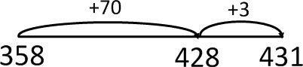  Fractions  Add and subtract fractions with the same denominator and related fractions; write mathematical statements >1 as a mixed number.  e.g.  2/5 + 4/5 = 6/5 = 1 and 1/5  Encourage estimation and the use of inverse to check answers.  Ensure that children know that addition is commutative (can be done in any order). | 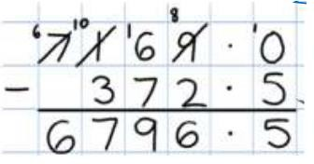  Number Lines  Children should identify when numbers are close together and finding the difference on an empty number line would be more appropriate.  e.g. 2013 – 1957 =  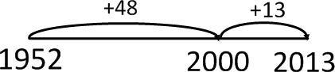  This would work for decimals too. e.g. 7.5 – 6.8  Fractions  Add and subtract fractions with the same denominator and related fractions; write mathematical statements >1 as a mixed number.  e.g.  6/5 - 4/5 = 2/5  or  1 and 1/5 – 4/5 = 2/5  Encourage estimation and the use of inverse to check answers.  Ensure that children know that subtraction is non-commutative (cannot be done in any order). | 256  x 3  1 1  768  Long Multiplication (multiplying by two or more digits)  Largest number on top, multiply each  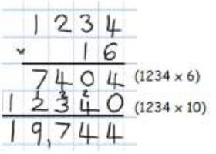  digit by the units, then underneath by the tens, then add)  Fractions  Multiply proper fractions and mixed numbers by whole numbers, supported by materials and diagrams.  e.g. 2/3 x 3 = 6/3 = 2 wholes  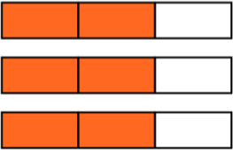  Encourage estimation and the use of inverse to check answers. | linking it to the next number, in this case 6. This makes 26.  “How many fives in 26?”  The answer is ‘5’ because 5 x 5 = 25. So you record a 5 above the 6. Then record the remaining 1 at the top.  Gradation of difficulty (short division)  1. TO ÷ O no exchange no remainder  2. TO ÷ O no exchange with remainder  3. TO ÷ O with exchange no remainder  4. TO ÷ O with exchange, with remainder  5. Zero in the quotient e.g. 816 ÷ 4 = 204  6. As 1-5 HTO ÷ O  7. As 1-5 greater number of digits ÷ O  8. As 1-5 with a decimal dividend e.g. 7.5 ÷ 5 or 0.12 ÷ 3  9. Where the divisor is a two digit number  Gradation of difficulty for expressing remainders  1. Whole number remainder  2. Remainder expressed as a fraction of the divisor  3. Remainder expressed as a simplified fraction  4. Remainder expressed as a decimal  ‘The Bar Model’  (links to fractions of amounts)  A fifth of 2000 is worth 400.  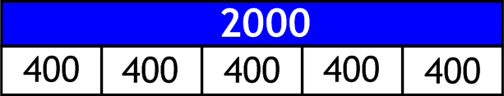  Encourage estimation and the use of inverse to check answers.  Ensure that children know that division is non-commutative (cannot be done in any order).

Year 6
Addition  + | Subtraction  – | Multiplication  x | Division  ÷
Children are expected to work with numbers with more than 4 digits.  Pictures/symbols/objects  Continue using a range of calculations as in Year 1, 2, 3, 4 and 5 but with appropriate numbers.  Column addition  Add larger numbers, including decimals up to 3 decimal places  e.g. 124.9 + 117.25 = 242.15  124.9  + 117.25  1 1  242.15  Revert to expanded methods if the children experience any difficulty.  Partitioning  Either partition both numbers and recombine or partition the second number only e.g.  35.8 + 7.3 = 35.8 + 7 + 0.3  = 42.8 + 0.3  = 43.1 | Children are expected to work with |  | Children are expected to identify
 | numbers with more than 4 digits. | Pictures/symbols/objects | common factors, common multiples and
 |  | Continue using a range of calculations as | prime numbers.
 | Pictures/symbols/objects | in Year 1, 2, 3, 4 and 5 but with
 | Continue using a range of calculations as | appropriate numbers. | Pictures/symbols/objects
 | in Year 1, 2, 3, 4 and 5 but with | Multiply multi-digit numbers up to 4 | Continue using a range of calculations as
 | appropriate numbers. | digits by a two-digit whole number using | in Year 1, 2, 3, 4 and 5 but with
 |  | the efficient written method of short (by | appropriate numbers.
 | Column subtraction (decomposition) | 1 digit) or long (by 2 digit) multiplication. | Divide numbers up to 4 digits by a two-
 | Subtract larger numbers including |  | digit whole number using the efficient
 | decimals up to 3 decimal places | Short Multiplication | written method of long division, and
 |  |  | interpret remainders as whole number
 | e.g. 347.6 – 143.25 = | As Y5 to multiply numbers up to 4 digits | remainders or fractions.
 | 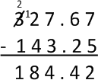  Number Lines  Find the difference of decimals by counting up.  e.g.  0.5 – 0.31 = 0.19  This can be modelled on an empty number line. | by 1 digit, money and measures and  decimals up to 2 decimals places  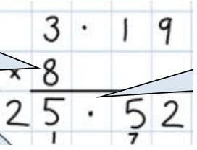 | (single digit)  NB: ‘Bus Stop’ is a trick and does not rely on place value.  Gradation of difficulty for expressing remainders  1. Whole number remainder  2. Remainder expressed as a fraction of the divisor  3. Remainder expressed as a simplified fraction  4. Remainder expressed as a decimal
 | 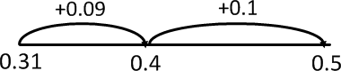 |  | ‘The Bar Model’  (links to fractions of amounts)
 |  |  | A fifth of 2000 is worth 400.

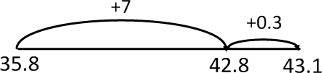  Fractions  Add and subtract fractions with different denominators and mixed numbers, using the concept of equivalent fractions.  2/3 + 5/6 = 4/6 + 5/6 = 9/6 = 1 3/6  Encourage estimation and the use of inverse to check answers.  Ensure that children know that addition is commutative (can be done in any order). | Fractions  Add and subtract fractions with different denominators and mixed numbers, using the concept of equivalent fractions.  1 3/5 – 4/10 = 1 3/5 – 2/5 = 1 1/5  Encourage estimation and the use of inverse to check answers.  Ensure that children know that subtraction is non-commutative (cannot be done in any order). | Long Multiplication Up to 4 digits by 2 digits. e.g. 5879 x 43 = 252,797  5879  x 43  2 2 2  17637  3 3 3  235160  1  252797  Fractions  Multiply simple pairs of proper fractions, writing the answer in its simplest form. e.g.  1/4 × 1/2 = 1/8  Multiply fractions and mixed numbers by whole numbers  1 1/3 x 3 = 4  Encourage estimation and the use of inverse to check answers.  Ensure that children know that multiplication is commutative (can be done in any order). | Long Division (by 2 digits) (This is the only time vertical chunking (grouping) should be used in the school!  (Numberline grouping Years 3 and 4)  (20)  (8)  Or  (Formal written method)
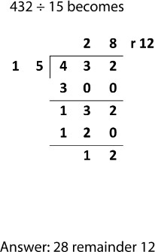
Grid Method

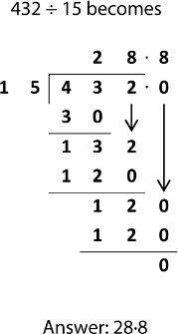

Fractions
Divide proper fractions by whole numbers.
e.g.
1/3 ÷ 2 = 1/6
Encourage estimation and the use of inverse to check answers.

Ensure that children know that division is non-commutative (cannot be done in any order).

Notes

  - GCA uses White Rose as a basis for planning and PA Plus (Herts for Learning for support)
  - All methods (apart from some in taught in Upper Key Stage 2) rely on a firm understanding of place value.
  - The teacher will always model what is expected.
  - Draw attention to correct vocabulary, e.g. ‘value’ of digits.
  - We use the vocabulary ‘hundreds, tens and ones’ not ‘hundreds, tens and units’. This stops any confusion with the term ‘unit of measurement’.
  - Always decide first whether a mental method or jottings are appropriate.
  - Children will always be encouraged to estimate the answer before attempting a written calculation.
  - Adults must model using the term ‘inverse’ where appropriate.
  - When using column subtraction, we ‘take’ from the next column. We don’t ‘borrow’, as the amount is never given back.
  - Division should be referred to as ‘grouping’, not ‘sharing’. This helps to cement the connection between division and multiplication (i.e. ‘groups of’).
  - Encourage children to always check the answer. Use their ‘number sense’ to ask themselves if the solution looks correct.
  - Encourage children to explain their strategies and reasoning.
  - Children who make persistent mistakes should return to the method that they can use accurately until ready to move on.
  - Discuss errors, misconceptions and diagnose problem and then work through problem.
  - When revising or extending to more challenging numbers, refer back to expanded methods. This helps reinforce understanding and reminds children that they have an alternative to fall back on if they are having difficulties.
  - Children need to know number and multiplication facts by heart.

Mental Calculations

Progression of mental calculation strategies
A range of mental calculation strategies should continue to be used. They are not replaced by written methods.
Addition  + | Subtraction  – | Multiplication  x | Division  ÷
Mental Calculations | Mental Calculations | Mental Calculations | Mental Calculations
Mental recall of number bonds | Mental recall of addition and | Doubling and halving | Doubling and halving
6 + 4 = 10, 7 + 3 = 10 | subtraction facts | Applying the knowledge of doubles and | Applying the knowledge of doubles and
25 + 75 = 100, 190 + 10= 200 | 10 – 6 = 4, 17 – 6 = 11 | halves to known facts. | halves to known facts.
 | 200 - 170 = 30, 100 - 87 = 13 | e.g. 8 x 4 is double 4 x 4 | e.g. 8 ÷ 4 is double 4 ÷ 4
Use near doubles
6 + 7 = double 6 + 1 = 13 | Find a small difference by | Knowing that doubling is multiplying by | Knowing that halving is dividing by 2.
 | counting up | 2.
Addition using partitioning and | 82 – 79 = 3 |  | Deriving and recalling division facts
recombining |  | Using multiplication facts | Year 2 – x2, x5, x10
34 + 45 = (30 + 40) + (4 + 5) = 79 | Counting on or back in repeated | Year 2 – x2, x5, x10 | Year 3 – x3, x4, x8
 | steps of 1, 10, 100, 1000 | Year 3 – x3, x4, x8 | Year 4 – Up to 12x12
Counting on or back in repeated | 86 - 52 = 34 (by counting back in | Year 4 – Up to 12x12
steps of 1, 10, 100, 1000 | tens and then in ones) |  | Using and applying division facts
86 + 57 = 143 (by counting on in tens | 460 - 300 = 160 (by counting back | Using and applying division facts | Children should be able to utilise their
and then in ones) | in hundreds) | Children should be able to utilise | tables knowledge to derive other facts.
460 - 300 = 160 (by counting back in |  | their tables knowledge to derive | e.g. If I know 21 ÷ 7 = 3, what else do I
hundreds) | Subtract the nearest multiple of | other facts. | know?
 | 10, 100 and 1000 and adjust | e.g. If I know 3 x 7 = 21, what else | 210 ÷ 7 = 30, 2100 ÷ 300 = 7, 21000 ÷ 7
Add the nearest multiple of 10, 100 | 24 - 19 = 24 - 20 + 1 = 5 | do I know? | = 3000, 2.1 ÷ 7 = 0.3 etc
and 1000 and adjust | 458 - 71 = 458 - 70 - 1 = 387 | 30 x 7 = 210, 300 x 7 = 2100, 3000
24 + 19 = 24 + 20 – 1 = 43 |  | x 7 = 21 000, 0.3 x 7 = 2.1 etc
458 + 71 = 458 + 70 + 1 = 529 |  |  | Dividing by 10 or 100
 |  |  | Knowing that the effect of dividing by
Use the relationship between | Use the relationship between | Use closely related facts already | 10 is a shift in the digits one place to
addition and subtraction | addition and subtraction | known | the right.
36 + 19 = 55 | 36 + 19 = 55 | 13 x 11 = (13 x 10) + (13 x 1) | Knowing that the effect of dividing by
19 + 36 = 55 | 19 + 36 = 55 | = 130 + 13 | 100 is a shift
55 – 19 = 36 | 55 – 19 = 36 | = 143

55 – 36 = 19  Points to remember:  - Use the language ‘calculation’  instead of ‘sum’ (‘sum’ means ‘plus or ‘total’).  - Use the language ‘digit’ or ‘integer’ instead of number (number is the  amount or quantity).  Addition vocabulary to be used through all stages.  add, addition, more, plus, increase, sum, total, altogether, score, double, near double, how many more to make…?, how many more/fewer is.. than…?, how much more/less is…?, is the same as, equals, sign, tens boundary, hundreds boundary, ones boundary, tenths boundary,  inverse. | 55 – 36 = 19  Points to remember:  Use the word exchange instead of borrow as the children may think they have to pay it back.  If you say exchange the children will know you are exchanging tens into units and nothing needs to be paid back.  Subtraction vocabulary to be used through all stages. subtract, take away, minus, decrease, leave, how many are  left/left over?, difference between, half, halve, how many more/fewer  is../than…?, how much more/less is…?, is the same as, equals, sign, tens boundary, hundreds boundary, ones boundary, tenths boundary, inverse | Multiplying by 10 or 100 Knowing that the effect of multiplying by 10 is a shift in the digits one place to the left.  Knowing that the effect of multiplying by 100 is a shift in the digits two places to the left.  Partitioning  23 x 4 = (20 x 4) + (3 x 4)  = 80 + 12  = 102  Use of factors (distributive law)  8 x 12 = 8 x 4 x 3  Multiplication vocabulary to be used through all stages.  groups of, times, product, multiply, multiplied by, multiple of, once, twice, three times, four times, five times,… ten times, repeated  addition, array, row, column, double,  halve, group in pairs, threes… tens, factor, quotient, inverse | Use of factors  378 ÷ 21 378 ÷ 3 = 126  378 ÷ 21 = 18 126 ÷ 7 = 18  Use related facts  Given that 1.4 x 1.1 = 1.54  What is 1.54 ÷ 1.4, or 1.54 ÷ 1.1?  Division vocabulary to be used through all stages.  lots of, groups of, times, product, multiply, multiplied by, multiple of, once, twice, three times, four times, five times,… ten times, repeated addition, array, row, column, double, halve, one each, two each, three  each…, group in pairs, threes… tens, group equally, equal groups of, divide, divided by, divided into, divisible by, remainder, factor, quotient, inverse
Children will need to develop their understanding of the inter-relationship between addition, subtraction, multiplication and division. They will learn that:
Addition and subtraction are inverse operations – that is, the opposite of one another. Adding 3 is the opposite of subtracting 3, so that if 6 + 3 = 9 then 9 – 3 = 6 Multiplication and division are also inverse operations.

