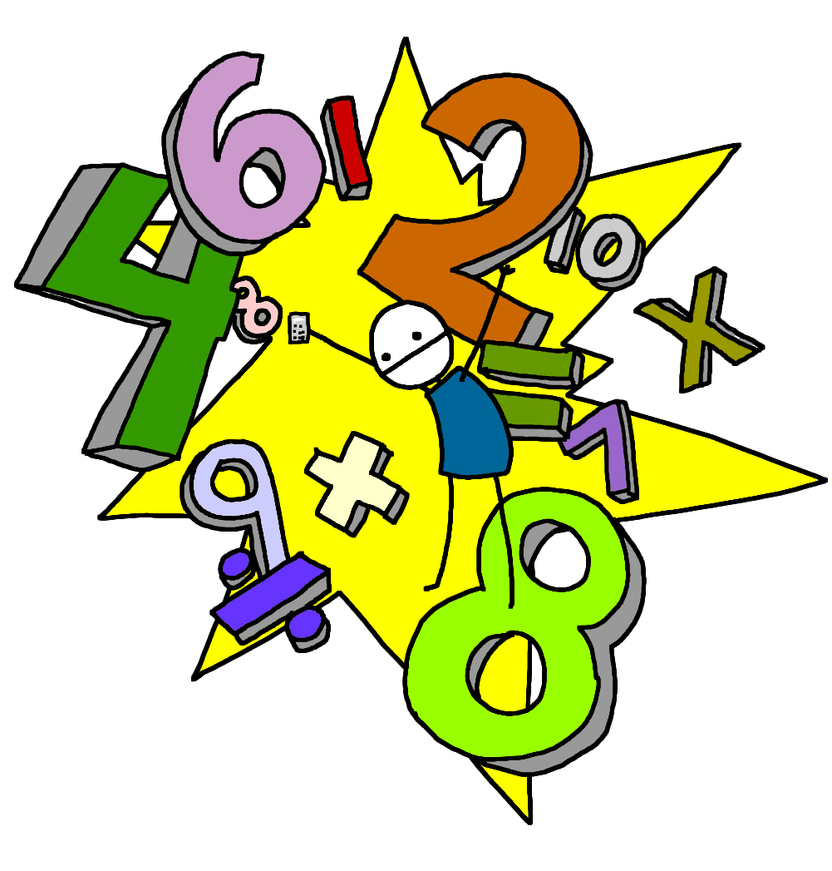
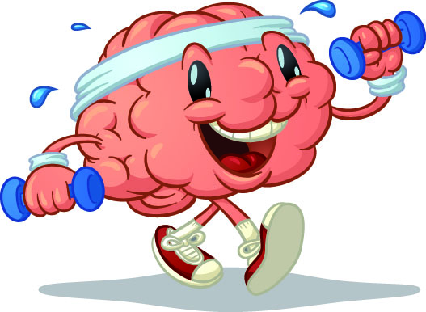
Morning Maths Workout!

Odd and even numbers

3 is an _____ number
5 is an _____ number
2 is an _____ number
8 is an _____ number
9 is an _____ number
10 is an _____ number
7 is an _____ number
1 is an _____ number
4 is an _____ number
6 is an _____ number
28 is an _____ number
42 is an _____ number
40 is an _____ number
38 is an _____ number
15 is an _____ number
99 is an _____ number
63 is an _____ number
77 is an _____ number
56 is an _____ number
29 is an _____ number
127 is an _____ number
421 is an _____ number
222 is an _____ number
896 is an _____ number
980 is an _____ number
105 is an _____ number
421 is an _____ number
196 is an _____ number
426 is an _____ number
619 is an _____ number

