SAFEGUARDING OFFICERS

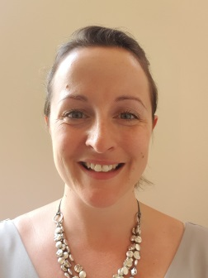
Designated Child Protection Officer
- Rachel Moss

Deputy Designated Child Protection Officer
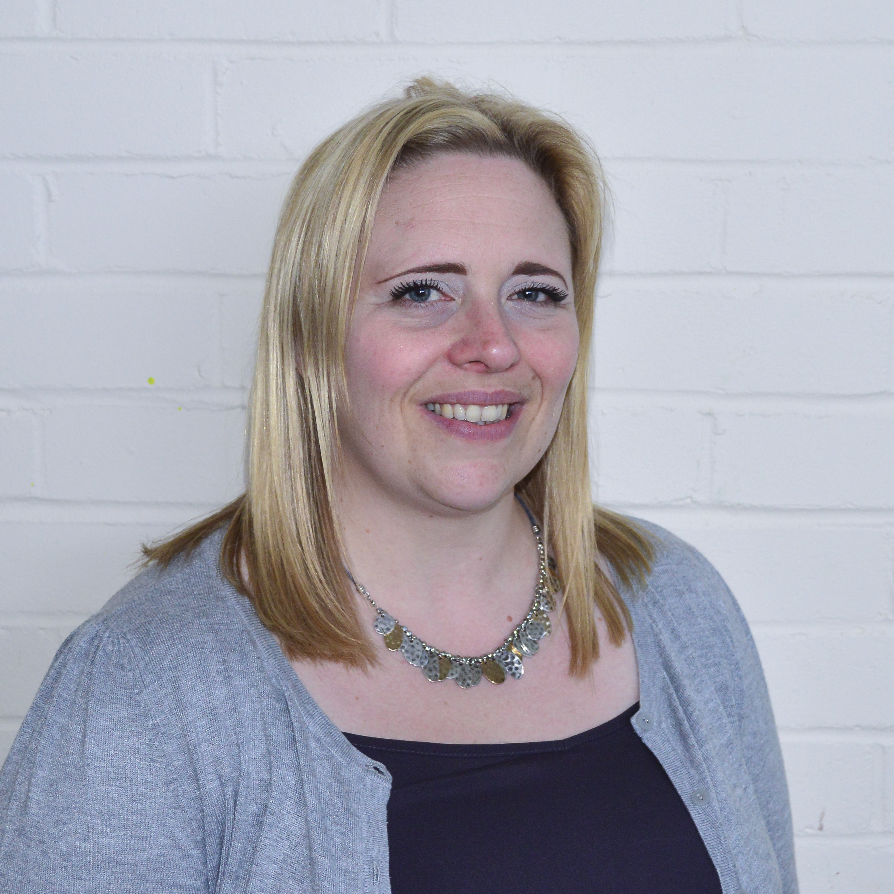
- Lora Churchill

- SAFEGUARDING GOVERNOR
David Wheatley

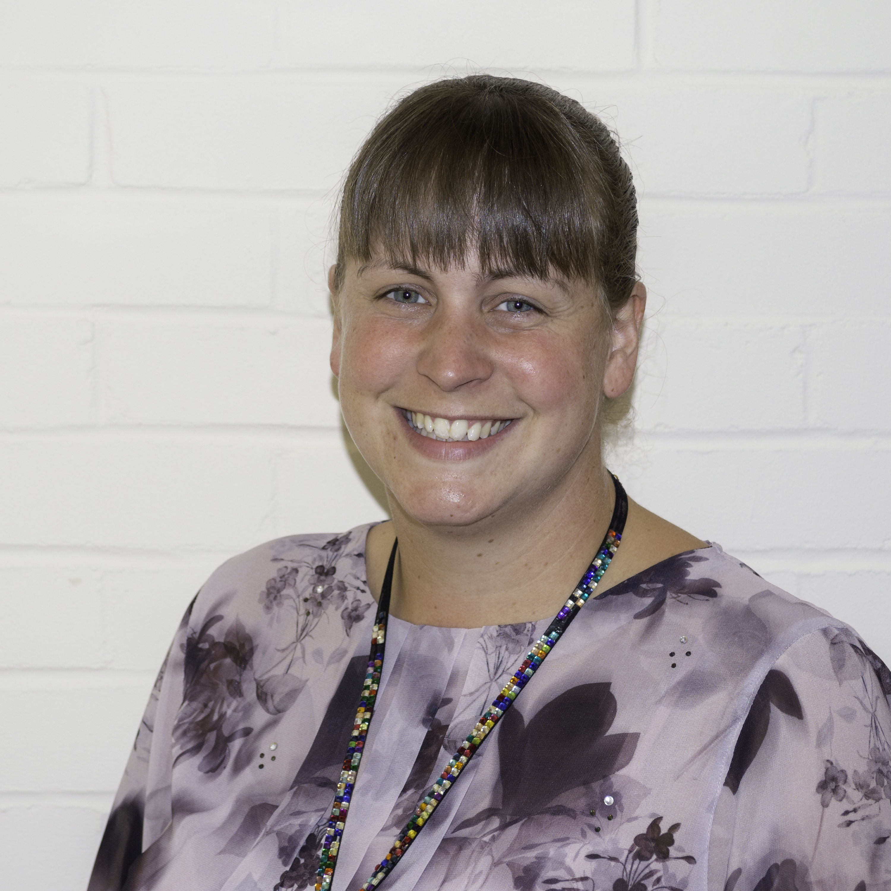
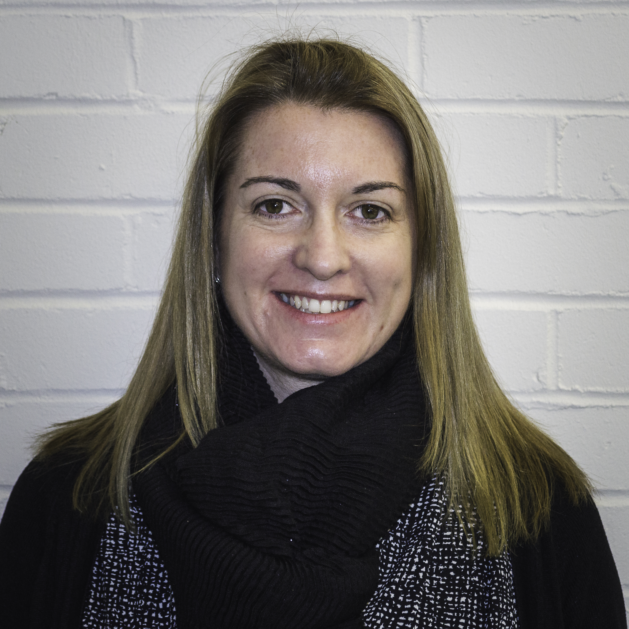
- IN ABSENCE OF DSPs
Rachael Stevenson Cara Judd

HOW TO REPORT A SAFEGUARDING CONCERN/INCIDENT

Thoroughly complete a Record of Concern form which is located in the staffroom at the bottom of the staff noticeboard

All information is to be recorded thoroughly and accurately

All Record of Concern forms must be handwritten and handed to one of the Safeguarding Officers immediately

In the absence of the Safeguarding Officers please hand to the Headteacher or Cara Judd

