Spring 2 Home Projects
Topic: Growing
Sorting Leaves:  Not all leaves look the same!  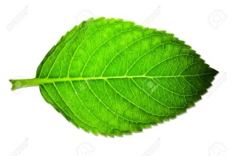  There are simple, compound (leaves with several leaves coming off the steam) and prickly leaves. See how many leaves you can find and sort them into groups. Take a picture of draw your findings. | Plants:  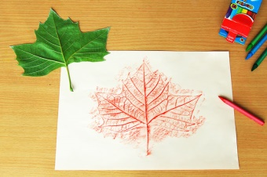  Find some interesting leaves and see if you can make rubbings of them using crayons or colouring pencils, or have a go at some flower pressing! | Cooking:  Can you make a dish that uses all parts of a plant? (Flower, stem, root and leaves).  Take a photo of your dish and bring it in to show.
Which plants grow in my garden?  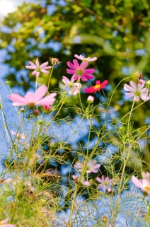  Find 4 different plants that grow in your garden (if yo don’t have a garden go to your nearest park), look and draw them carefully. If you know what they are called have a go at labelling them. | Plant diary:  Can you plant a seed? Keep a diary of how it grows each day, you can draw or take photos of its progress.  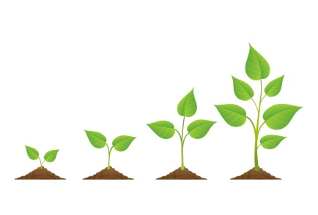 | Music:  Find a short poem or song for our topic growing; can you perform it to the class?

