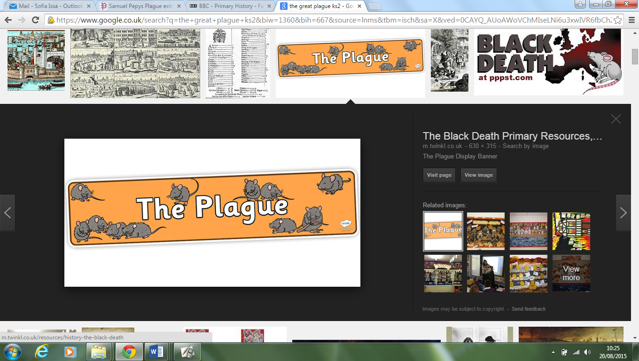

Year 4 -Home learning tasks (autumn term 1)

Create a map of London in 1665 or make it 3D using lego, junk modelling etc!

[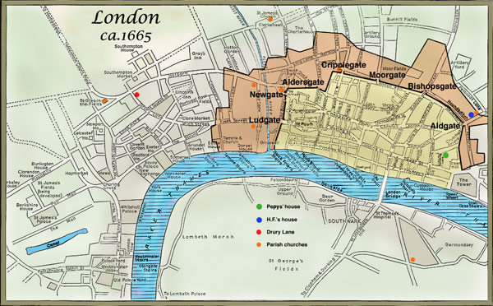](https://www.google.co.uk/url?sa=i&rct=j&q=&esrc=s&source=images&cd=&cad=rja&uact=8&ved=0ahUKEwjVn7jp2uXVAhUGDxoKHYcOCfEQjRwIBw&url=https://faculty.humanities.uci.edu/bjbecker/PlaguesandPeople/lecture12.html&psig=AFQjCNGmdOemMg5VYlGZJ6ZIL26hKmmcdA&ust=1503314967621728)

Invent your own medicine as a remedy for the plague. You can write about this, make it using liquids or design a bottle with labels stating what it contains.



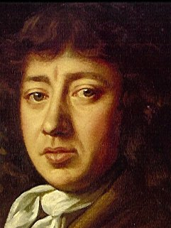What can you find out about Samuel Pepys? You can view his diary at Magdalene College in Cambridge: <http://www.magd.cam.ac.uk/pepys/>

Create a flow diagram on how the plague spread from fleas to humans – remember to draw and label it.

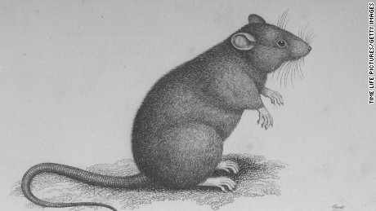

**Research the plague doctors.** 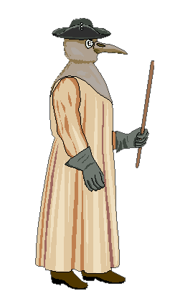Why did they dress the way they did? Draw and label their outfit.

Imagine you are a child living in London in 1665. Write about the terrible plague. It could be a story, play, letter or diary entry.

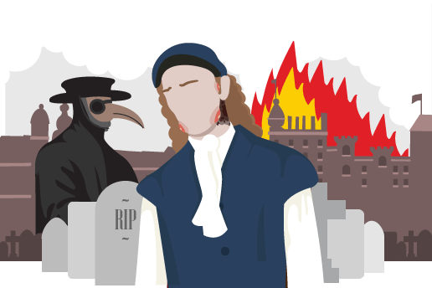

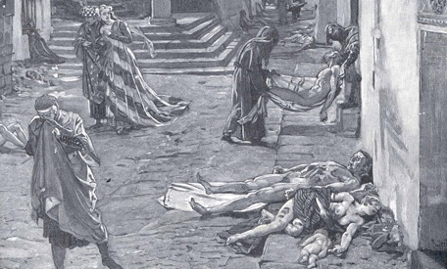Design a poster warning people about the Plague and suggesting ways they can prevent themselves from catching it.

**Write an acrostic poem about the plague.**

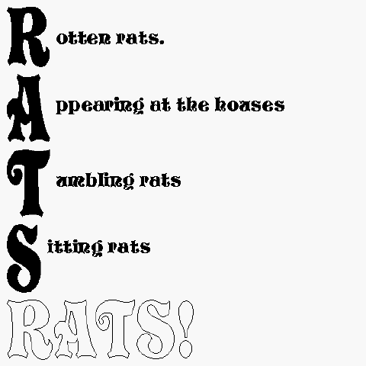

Make a plague doctor’s mask using any material of your choice.

