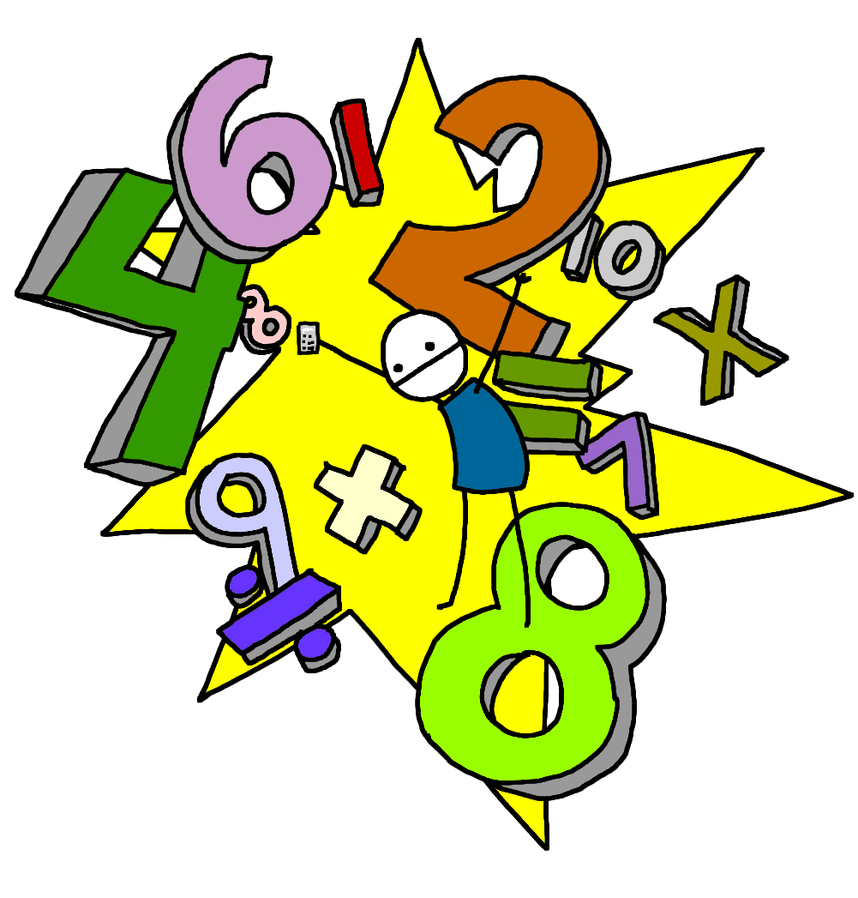
Morning Maths Workout!

Multiples of 2, 3, 5 or 10

6 is a multiple of __________
15 is a multiple of __________
30 is a multiple of __________
9 is a multiple of __________
45 is a multiple of __________
8 is a multiple of __________
2 is a multiple of __________
10 is a multiple of __________
20 is a multiple of __________
90 is a multiple of __________
5 is a multiple of __________
50 is a multiple of __________
28 is a multiple of __________
16 is a multiple of __________
35 is a multiple of __________
15 is a multiple of __________
12 is a multiple of __________
14 is a multiple of __________
40 is a multiple of __________
60 is a multiple of __________

