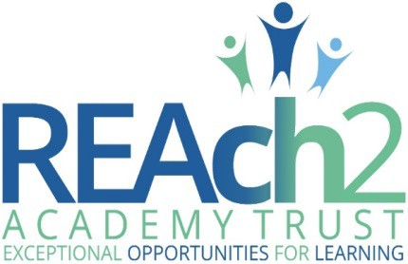

Whistleblowing policy

Audience: | Parents  Trust employees, contractors and volunteers Local Governing Bodies  Trustees  Regional Boards
Approved: | Trustees – July 2017
Other related policies: | Code of Conduct; Disciplinary; Grievance
Policy owner: | Michelle Roe, Internal Auditor
Policy model: | Compliance: the whole Trust uses this policy
Review: | 2018/19
Version number: | 1.1 (July 2017)

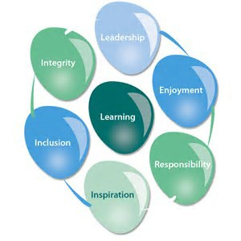
REAch2 whistleblowing policy

At REAch2, our actions and our intentions as school leaders are guided by our Touchstones:

Integrity | We recognise that we lead by example and if we want children to grow  up to behave appropriately and with integrity then we must model this behaviour
Responsibility | We act judiciously with sensitivity and care. We don’t make excuses, but mindfully answer for actions and continually seek to make improvements
Inclusion | We acknowledge and celebrate that all people are different and can play a role in the REAch2 family whatever their background or learning style
Enjoyment | Providing learning that is relevant, motivating and engaging releases a child’s curiosity and fun, so that a task can be tackled and their goals achieved
Inspiration | Inspiration breathes life into our schools. Introducing children to influential experiences of people and place, motivates them to live their lives to the full
Learning | Children and adults will flourish in their learning and through learning discover a future that is worth pursuing
Leadership | REAch2 aspires for high quality leadership by seeking out talent, developing potential and spotting the possible in people as well as the actual

Contents
What is whistleblowing? | 4
The Trust’s commitments to employees who whistle-blow | 5
Whistleblowing procedures  Making the disclosure as an employee | 6  6
Managing a Disclosure as a manager | 7
Managing a Disclosure Meeting | 8
Assessing the Disclosure | 9
Role of Internal Auditor | 9
Trustee Risk and Audit Committee | 11
Feedback to employees who are whistleblowing | 11
Independent information and advice for employees concerned about ‘blowing the whistle’ | 12
Blowing the whistle to the relevant prescribed person(s) | 12
Supporting colleagues who have ‘blown the whistle’ | 12
Training and development | 13
Annex – whistleblowing flowchart | 14

What is Whistleblowing?
REAch2 Academy Trust is committed to achieving the highest possible standards of service and ethical standards and this policy will enable workers to raise their concerns of serious wrongdoing without fear of reprisal.
This policy applies to all individuals working for REAch2 Academy Trust at all levels and grades, whether they are employees, contractors and casual or agency staff. Although legislation only applies to paid workers, best practice is for policies also to apply to volunteers and non-executives (such as governors). REAch2 Academy Trust therefore envisages this policy being used in relation to such individuals as potential whistleblowers, with the protection that goes with that, but also as parties who may be cited in a whistleblowing disclosure. References in this policy to employees or workers should therefore be read as also applying to volunteers including governors.
Whistleblowing is the term used when an employee makes a disclosure concerning wrongdoing. The wrongdoing will typically (although not necessarily) be something they have witnessed at work.
To be covered by whistleblowing law, a worker who makes a disclosure must reasonably believe two things:
The first is that they are acting in the public interest. This means that personal grievances and complaints are not covered by this whistleblowing policy.
Personal grievances or complaints must be raised through the Trust’s grievance procedure;
The second thing that a worker must reasonably believe is that the disclosure tends to show past, present or likely future wrongdoing falling into one or more of the following categories:
- Criminal offences (this may include, for example, types of financial impropriety such as fraud)
- Failure to comply with an obligation set out in law
- Miscarriages of justice
- Endangering of someone’s health and safety including safeguarding of children
- Damage to the environment
- Covering up wrongdoing in the above categories
Whistleblowing law is located in the Employment Rights Act 1996 (as amended by the Public Interest Disclosure Act 1998. This can be seen at http://www,opsi.gov.uk/acts/acts1998). It provides the right for a worker to take a case to an employment tribunal if they have been victimised at work or they have lost their job because they have ‘blown the whistle’.

The Enterprise and Regulatory Reform Act 2013 (ERRA)
This came into force on 25 June 2013 and introduced a number of changes to Whistleblowing legislation. A worker will be eligible for protection if they honestly think what they’re reporting is true and they think they’re telling the right person. From 25 June 2013, the new law says that a whistleblower should also believe that their disclosure is in the public interest.
The Whistleblowing procedure must always be applied fairly and in accordance with employment law and the REAch2 Equal Opportunities Policy.

The Trust’s commitments to employees who whistle-blow
- REAch2 Academy Trust considers it a professional duty for employees to make a disclosure where they are aware of or strongly suspect wrongdoing.
- Employees who make a disclosure (‘blow the whistle’) will be fully supported and protected by the Trust.
- The Trust will treat all disclosures in a consistent and fair way.
- Victimisation or intimidation of a whistleblower will not be tolerated in the Trust and would be considered a gross misconduct. Any perceived victimization or intimidation of an employee making a disclosure will be formally investigated as a potential disciplinary matter.
- Employees making a disclosure are entitled to seek the advice and support of their Trade Union or professional association if they wish.
- Subject to the Trust’s Data protection obligations, employees making a disclosure will receive feedback about the outcome of their disclosure.
- All cases of whistleblowing will be brought to the attention of the Trust’s Internal Auditor and the Trustees who sit on the Trust’s Risk and Audit Committee.

Whistleblowing Procedures

Making the disclosure as an employee
- Who should an employee disclose to?
  - Employees or volunteers based in a school should make their disclosure to the Headteacher or Deputy Headteacher who will determine if they can take the disclosure forward or need to escalate it to a more senior level. If a governor has a disclosure to make about another governor, they should make this to the chair of governors; if the disclosure concerns the chair of governors, it should be made to the Headteacher.
  - Employees centrally employed by the Trust should make their disclosure to their line manager who will determine if they can take the disclosure forward or need to escalate it to a more senior level.
  - If an employee has concerns about making the disclosure to their Headteacher / Deputy Headteacher or line manager, for whatever reason, then they may make a disclosure to the Internal Auditor who will identify the appropriate professional to take the matter forward.
  - An employee may wish to take advice from their Trade Union or professional association before deciding whom to disclose to but there is no requirement to do this.
  - Even where extreme circumstances are thought to exist, an employee should not approach the media with details of the suspected wrongdoing. If they do so, the Trust may consider this to be gross misconduct and disciplinary action may be taken against them.

What information should the employee provide with their disclosure?
  - In making a disclosure an employee needs to be clear about why they think wrongdoing has occurred or is occurring or is going to occur.
  - If the employee has evidence to support their disclosure they should have it available.
  - If the employee does not have evidence to support their disclosure but still suspect that there may have been wrongdoing that is fine. They must be clear about why they suspect that wrongdoing has occurred or is occurring.

Can a disclosure be anonymous?
  - Disclosures can be made anonymously. However, it is much more difficult to investigate anonymous disclosures and of course it will not be possible to provide feedback to such a whistleblower.

Managing a Disclosure as a Manager
- Receiving a disclosure.
  - If a colleague informs their manager that they wish to disclose a concern or a suspicion of wrongdoing that may constitute whistleblowing, then the issue must be dealt with seriously and sensitively.
  - It is important that whistleblowing disclosures are dealt with in a consistent manner. Managers should provide the whistleblower with a copy of this policy which is also available on the REAch2 website.
  - Reassure the whistleblower that their disclosure will not affect their position at work.
  - This may be a difficult or anxious time for the whistleblower, they must be reassured that they will be protected and supported by the Trust. If they are a member of a Trade Union or professional association they need to be told that they may take advice before proceeding but they don’t have to. They are doing nothing wrong.
  - At this point the manager should ask for an outline of the concerns to help them ascertain how urgent the matter is and whether it needs to be escalated to a more senior level immediately. If the matter needs to be escalated then the manager should do so immediately.
  - The manager should contact the Regional HR Consultant or Director of HR immediately for support and advice.
  - The manager should consider whether the nature of the disclosure in outline is likely to meet the test of whistleblowing rather than personal grievance: the concern is in the public interest; that it relates to potential wrongdoing that meets the test of whistleblowing.
  - The manager should arrange a time for a formal meeting at which they will want to gather all of the information to better understand the situation. The meeting should be held as soon as is reasonably possible. The whistleblower is entitled to have a Trade Union or professional association representative accompany them at the meeting.
  - The manager should formally inform their line manager that they are dealing with a disclosure and let them know the nature of the disclosure. The manager should maintain confidentiality about the identity of the whistleblower within the limits that have been

explained to the whistleblower. Where appropriate (e.g. where the issue could affect matters that governors oversee or could have an impact at strategic rather than operational level), the Headteacher should inform the chair of governors that a whistleblowing disclosure is being managed.

Managing a Disclosure Meeting
  - It is the responsibility of the senior manager hosting a disclosure meeting to ensure that the whistleblower is put at their ease, as far as is reasonable possible, and that the mood of the meeting is professional but supportive. The priority at this stage is to listen to the whistleblower and understand their concern.
  - A summary record of the meeting must be made and a copy provided to the whistleblower.
  - A manager must gather all of the information available so that you can fully understand the nature of the concern and who may be involved.
  - To be provided with evidence is very helpful. However, it is legitimate for a whistleblower to share a concern or suspicion for which they do not have evidence. In this case, try to ascertain the basis for the suspicion.
  - The whistleblower should be reassured that to disclose a genuinely held suspicion that later proves to be wrong is fine. There are no negative consequences for someone who discloses a genuinely held suspicion whether right or wrong.
  - Once the manager has all of the information they must explain to the whistleblower what will happen next:
    - An assessment will be made in consultation with Trust senior managers as to whether enough information is available to come to a conclusion about what action to take next or whether a formal investigation is required to gather further information.
    - Once all of the necessary information and evidence is available the Trust will determine the appropriate action to take.
    - If the appropriate action includes potential processes involving other employees then the Trust also has a duty of care and duty of confidentiality towards those employees. It will not be possible therefore to feedback to the whistleblower about specific processes or actions applied to other individuals. It is possible however that under some circumstances the whistleblower may be asked to be a witness if formal

procedures are instigated.
    - The whistleblower should be given clear timescales for when they can expect feedback on the outcome of their disclosure.

Assessing the Disclosure
  - Following the disclosure meeting and in consultation with a member of the HR team and the manager’s line manager they need to decide whether there is enough information available to come to a conclusion about the disclosure. The possible conclusions are:
    - The disclosure meets the whistleblowing criteria and needs to be progressed to a formal investigation.
    - The disclosure is based on a misunderstanding of legitimate behaviours by other staff.
    - The disclosure constitutes a personal grievance rather than whistleblowing.
    - The disclosure is potentially malicious.
  - The conclusion reached must be based on: the evidence available; objective assessment; treating all individuals potentially involved equitable and fairly; based on the principles of natural justice.
  - The conclusion reached must take note of the views of the HR advice and your line manager’s views. However, the conclusion is the one that the manager genuinely holds after taking account of all of the information available to them and having taken advice.
  - The manager’s conclusion, along with a summary of the disclosure and the information available must then be recorded and then sent directly to the Internal Auditor and, where appropriate (see 4.i above), copied to the chair of governors.
  - The Internal Auditor will then formally advise you of the next steps.
  - If you suspect that a criminal offence has occurred, then there must be no further attempt to collect evidence or take witness statements. Such actions may undermine a police criminal investigation by tainting evidence. The Internal Auditor must be advised immediately who will advise on the next steps.
Contact details of the Internal Auditor: Michelle Roe
Telephone: 07387411652 Email: michelle.roe@reach2.org

Role of the Internal Auditor
  - The Internal Auditor will consider the ‘CONFIDENTIAL – Whistleblowing Disclosure Assessment’ and determine the next steps depending on the circumstances and context of the disclosure. An example of next steps is provided as follows but this is not an exhaustive list:
    - Determine that potentially there has been a breach of professional standards that require a further fact finding exercise, an investigation or a formal internal disciplinary investigation to be carried out.
      - The Internal Auditor will initiate the appropriate internal investigation processes.
      - The Internal Auditor will authorize the manager that received the disclosure to feedback to the whistleblower that a formal investigation into their concern has been initiated.
    - Determine that there has been a breach of criminal law.
      - The Internal Auditor will authorize the appropriate manager to inform the police immediately.
      - The Internal Auditor will take all reasonable measures to ensure that the Trust employees do not initiate any further actions or communications that might compromise a police criminal investigation.
    - Determine that the disclosure was a misunderstanding of the legitimate actions of other staff.
      - The Internal Auditor will authorize the manager that received the disclosure to feedback the finding to the whistleblower and to provide them with all of the necessary information, evidence and support to satisfy them that the behaviours that they were concerned about were legitimate and appropriate.
    - Determine that the disclosure constituted a personal grievance rather than whistleblowing.
      - The Internal Auditor will authorize the Director of HR to take the necessary steps to provide the ‘whistleblower’ with the appropriate support and guidance for managing a grievance and to understand the difference between grievance and whistleblowing.

    - Determine that the disclosure was potentially malicious.
      - A determination of a disclosure being potentially malicious requires a high standard of evidence to justify the determination. The Trust seeks to encourage whistleblowing in good faith and to that end whistleblowers must be reassured that a disclosure made in good faith will never lead to a detrimental position for their employment. A knowingly false disclosure however would constitute a mis-conduct in itself.
      - The Internal Auditor will authorize the Director of HR to make the necessary arrangements for a disciplinary investigation to be initiated.
  - The Internal Auditor will maintain a central record of all ‘CONFIDENTIAL – Whistleblowing Disclosure Assessments’ and the actions and outcomes that were taken.
  - The Internal Auditor will provide the agreed report of the concern and the actions taken to the Chief Executive Officer.

Trustee Risk and Audit Committee
- The Internal Auditor will provide the agreed confidential report to the Trust’s Risk and Audit Committee setting out the circumstances and actions taken for all whistleblowing disclosures. The identity and confidentiality of the whistleblower will be protected in these reports and not disclosed.
- The Risk and Audit Committee will consider the wider implications and lessons learnt for the Trust. These considerations will include whether policy and procedures could be improved to better protect the interests of the Trust in the future.
- The Chair of the Risk and Audit Committee, which may be by way of delegation to the Internal Auditor, will liaise with the Chairs of the relevant Regional Board Risk and Audit Committee and/or of the Local Governing Body to ensure that outcomes of a whistleblowing disclosure can inform the context of the work of the regional committee and LGB.
- The Risk and Audit Committee has the authority to initiate further investigations if they consider it necessary.

Feedback to employees who are whistleblowing
- Wherever possible feedback will be provided to the employee who raised the disclosure within the limits of the law and the duty of confidentiality to other members of staff.
- The manger that conducted the disclosure interview should provide the employee that raised the concern with an estimate of the timings for next steps and actions.
- The whistleblowing procedures provide examples of the nature of specific types of feedback under certain circumstances. The limits of information that can be fed back must be made clear at the outset.
- The employee who raised the concern should be told when the process has been concluded and what the conclusion was but again within the limits of law and duty of confidentiality to other employees.

Independent information and advice for employees concerned about ‘blowing the whistle’
- Independent information and advice for employees concerned about whistle blowing can be obtained from their trade union or professional association.
- Information can also be obtained from the ‘Public Concern at Work’ website http://www.pcaw.org.uk

Blowing the whistle to the relevant prescribed person(s)
In general if a worker makes a disclosure to an external body they may lose their whistleblowing rights and protections. There are some exceptions to this however, known as prescribed people and bodies. A full list of such people and bodies can be downloaded at https://www.gov.uk/government/publications/blowing-the-whistle-list-of- prescribed-people-and-bodies--2

The list includes, but is not limited to, the following:
- The police
- The DfE/EFA
- Member of Parliament
- National Audit office
- Health and Safety Executive (HSE)

Supporting colleagues who have ‘blown the whistle’
Making a disclosure where one suspect that wrongdoing has, is or is about to happen, is a professional duty. However, it may still be a difficult, stressful and anxious situation for many people. Whistleblowing is about doing the right thing with integrity. Those who step forward to do the right thing must be fully supported throughout the process and afterwards. They must be provided with clear lines of communication where they can get support from within the organisation. Whistleblowers will be provided with direct contact information for the Regional HR Consultant who can provide advice, support and interventions if required.

Training and Development
- All team leaders, school based and central teams, will provide training opportunities for staff on the process of making a disclosure annually. The process will be included in all staff induction.
- All team leaders will ensure that managers that might conduct a disclosure interview are familiar with the process and that this is refreshed on an annual basis.
- The Trust’s HR team will maintain a central register of training completed for each school and team that will be updated annually.

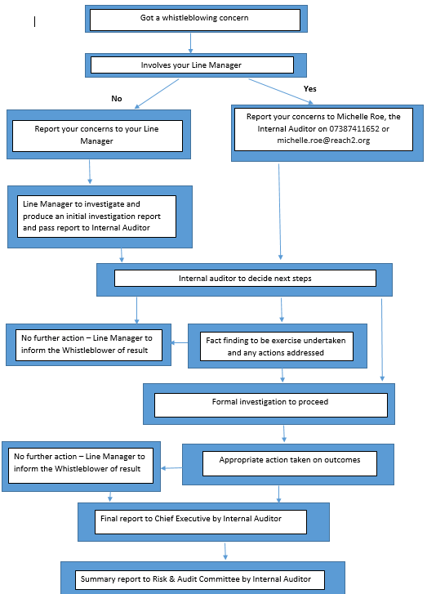
Annex – whistleblowing flowchart

