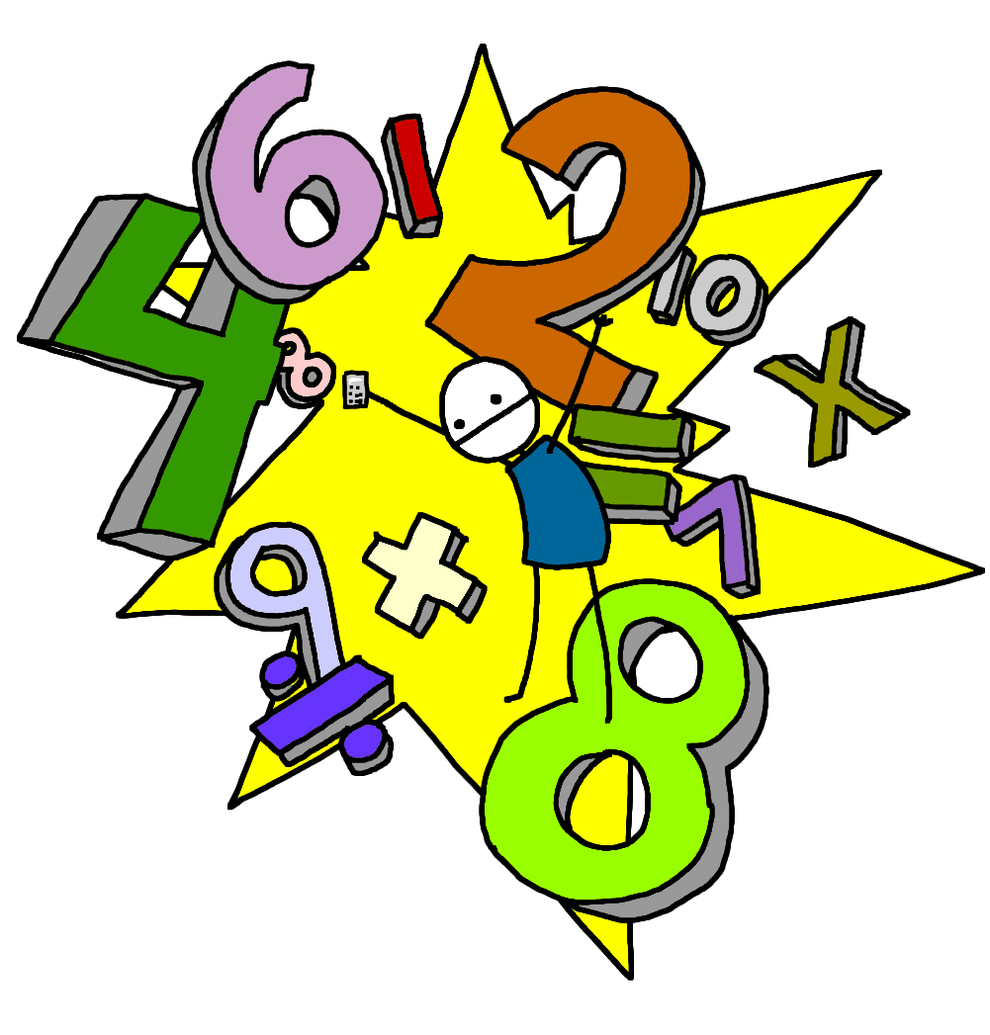
Morning Maths Workout!

2, 5 and 10 times tables

4 x 2 =
7 x 2 =
5 x 2 =
2 x 2 =
10 x 2 =
3 x 2 =
9 x 2=
1 x 2 =
6 x 2 =
8 x 2 =
4 x 5 =
7 x 5 =
5 x 5 =
2 x 5 =
10 x 5 =
3 x 5 =
9 x 5=
1 x 5 =
6 x 5 =
8 x 5 =
4 x 10 =
7 x 10 =
5 x 10 =
2 x 10 =
10 x 10 =
3 x 10 =
9 x 10 =
1 x 10 =
6 x 10 =
8 x 10 =

